FULL STACK DEVELOPMENT WITH MERN
House Rent Management System
HouseHunt / RentEase

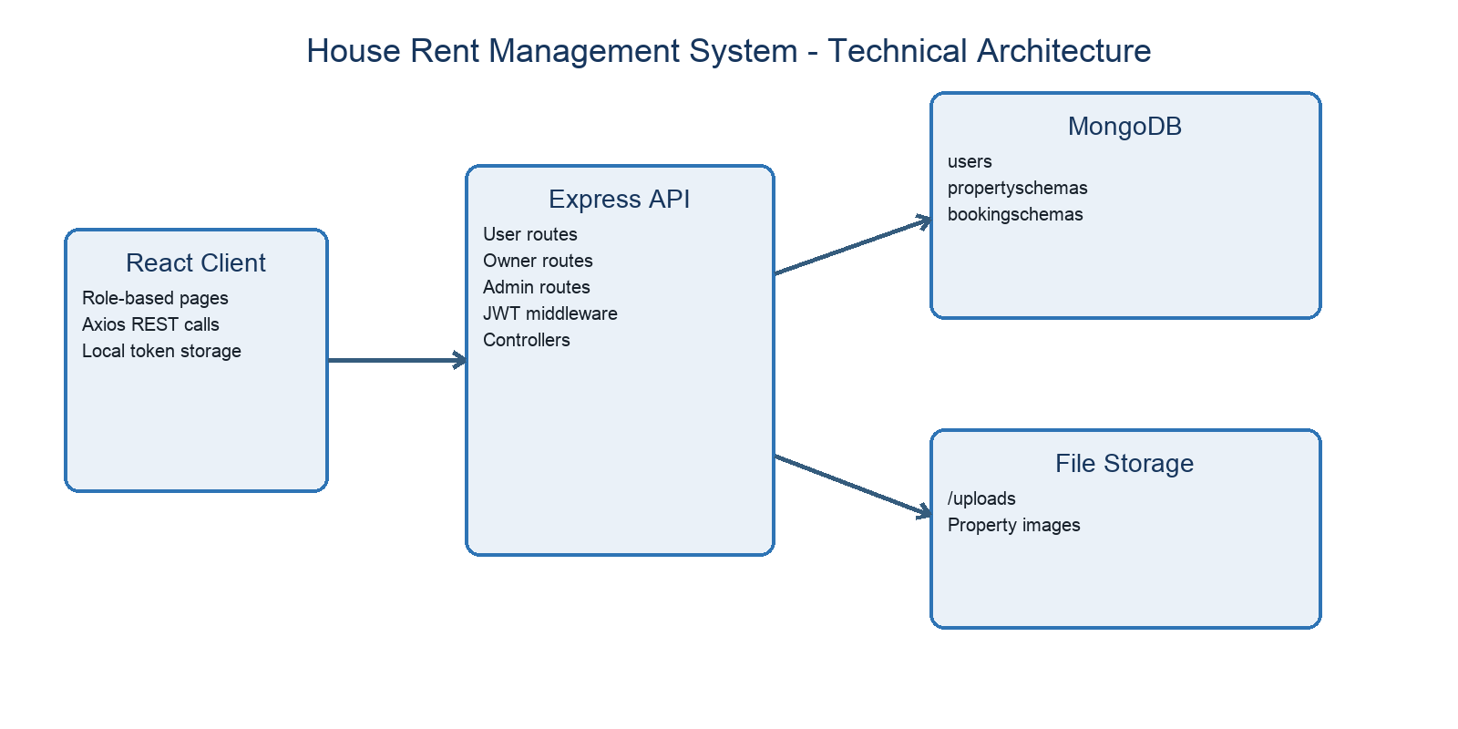
Project Documentation
Submitted by
Duvva Naveen (Team Lead)
Addepalli Ramya Hari Priya Varshini (Team Member)
Nandikolla Usha Sri (Team Member)
Haripriya Godaba (Team Member)
Narayana Murthy Perapu (Team Member)
Under the guidance of M. Sarit Sir | July 2026

1. Introduction
Field | Details
Project Title | House Rent Management System (HouseHunt / RentEase)
Repository | https://github.com/naveenduvva692004-collab/house-rent-master
Academic Context | Full Stack Development with MERN
Team Lead | Duvva Naveen
Team Members | Addepalli Ramya Hari Priya Varshini; Nandikolla Usha Sri; Haripriya Godaba; Narayana Murthy Perapu
This report is based on the repository's current code, the supplied project document, the required Google Drive MERN documentation format, and the phase structure demonstrated in the reference project. Inaccurate copied references from the earlier draft have been removed.

2. Project Overview

Purpose
The House Rent Management System centralizes property discovery, owner listing management, rental booking requests, and administrator oversight in a single MERN web application. It is intended as an academic full-stack demonstration rather than a production real-estate marketplace.

User Roles
Role | Capabilities
Renter | Register, log in, browse/filter properties, submit booking details, and view booking history.
Owner | Register, await administrator approval, manage property listings/images, review bookings, and update status.
Admin | View users, approve or revoke owner access, and review all properties and bookings.

Implemented Features
- Role-aware registration and navigation.
- bcrypt password hashing and JWT authentication.
- Property browsing and filters for address, property type, and ad type.
- Owner property CRUD and multiple image upload.
- Booking request and booking-history flow.
- Administrator approval and monitoring views.

3. Architecture
Figure 1. Technical architecture derived from the repository.

Frontend
React 18 renders public pages and role dashboards. React Router defines routes, Axios calls the API, and Material UI, Ant Design, Bootstrap, and React Bootstrap provide interface components. Login information and the JWT are stored in localStorage.

Backend
Node.js and Express expose user, owner, and administrator routes. Route modules call controllers, and a JWT middleware protects selected operations. Express also serves property images from the backend/uploads directory.

Database
Mongoose connects the API to MongoDB. Three collections model users, properties, and bookings. The current schemas are flexible because strict mode is disabled, which accommodates fields such as granted and isAvailable but also permits spelling inconsistencies.
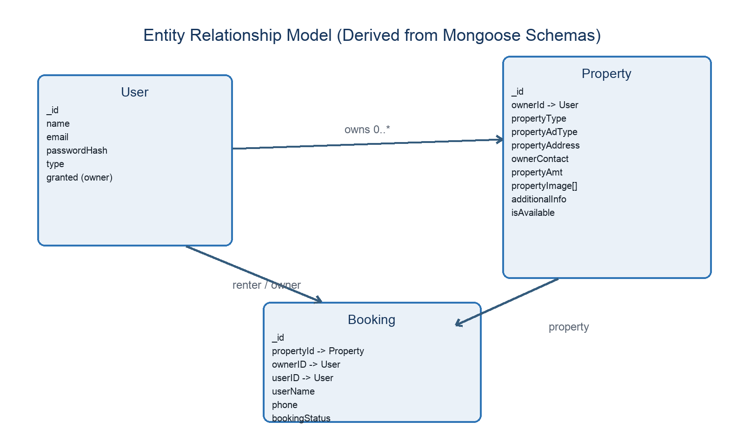
Figure 2. Entity relationship model reconstructed from Mongoose schemas.

4. Setup Instructions

Prerequisites
- Node.js with npm.
- MongoDB Community Server or a MongoDB Atlas database.
- Git.
- Modern browser and code editor.

Installation
git clone https://github.com/naveenduvva692004-collab/house-rent-master.git
cd house-rent-master/backend
npm install
# create backend/.env (see below)
npm start
# new terminal
cd house-rent-master/frontend
npm install
npm start

Backend .env
PORT=8001
MONGO_DB=mongodb://127.0.0.1:27017/house_rent
JWT_KEY=replace_with_a_long_random_secret

5. Folder Structure
frontend/src/
├── App.js # routes and role dashboards
├── images/ # bundled images
└── modules/
├── common/ # home, register, login, forgot password
├── admin/ # users, properties, bookings
└── user/{Owner,renter}/ # role-specific pages
backend/
├── config/connect.js # MongoDB connection
├── controllers/ # business logic by role
├── middlewares/authMiddlware.js # JWT validation
├── routes/ # Express route definitions
├── schemas/ # Mongoose data models
├── uploads/ # property images
└── index.js # application entry point

6. Running the Application
Service | Directory | Command | Default Address
Backend API | backend | npm start | http://localhost:8001 when PORT=8001
Frontend | frontend | npm start | http://localhost:3000
The frontend source currently hard-codes port 8001. If PORT is omitted, the backend falls back to 8000 and client requests will fail. Use PORT=8001 or refactor the client to read REACT_APP_API_BASE_URL.

7. API Documentation
Method | Endpoint | Auth | Purpose
POST | /api/user/register | Public | Create renter or owner account
POST | /api/user/login | Public | Authenticate and return JWT + user
POST | /api/user/forgotpassword | Public | Replace password by email (unsafe as implemented)
GET | /api/user/getAllProperties | Public | List all properties
POST | /api/user/getuserdata | JWT | Return authenticated user
POST | /api/user/bookinghandle/:propertyid | JWT | Create pending booking
GET | /api/user/getallbookings | JWT | List bookings for authenticated renter
POST | /api/owner/postproperty | JWT + multipart | Create property with images
GET | /api/owner/getallproperties | JWT | List authenticated owner's properties
GET | /api/owner/getallbookings | JWT | List bookings for authenticated owner
POST | /api/owner/handlebookingstatus | JWT | Update booking and availability
DELETE | /api/owner/deleteproperty/:propertyid | JWT | Delete property
PATCH | /api/owner/updateproperty/:propertyid | JWT + multipart | Update property
GET | /api/admin/getallusers | JWT | List all users
POST | /api/admin/handlestatus | JWT | Grant or revoke owner access
GET | /api/admin/getallproperties | JWT | List all properties
GET | /api/admin/getallbookings | JWT | List all bookings

Example Login Request
POST /api/user/login
{
"email": "renter@example.com",
"password": "example-password"
}

Example Success Shape
{
"message": "Login success successfully",
"success": true,
"token": "<jwt>",
"user": { "_id": "...", "name": "...", "email": "...", "type": "Renter" }
}

8. Authentication and Authorization
- Registration hashes the password with bcrypt using a generated salt.
- Login compares the supplied password to the stored hash.
- A JWT containing the user ID is signed with JWT_KEY and expires after one day.
- Protected requests send Authorization: Bearer <token>.
- The middleware verifies the token and writes the decoded ID to req.body.userId.
Security limitation: the backend verifies identity but does not enforce role-based authorization. An authenticated renter could attempt owner or admin endpoints. Add server-side role middleware before production use.

9. User Interface
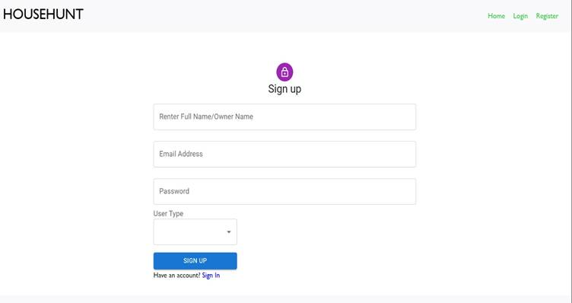
Figure 3. Registration interface from the supplied project document.
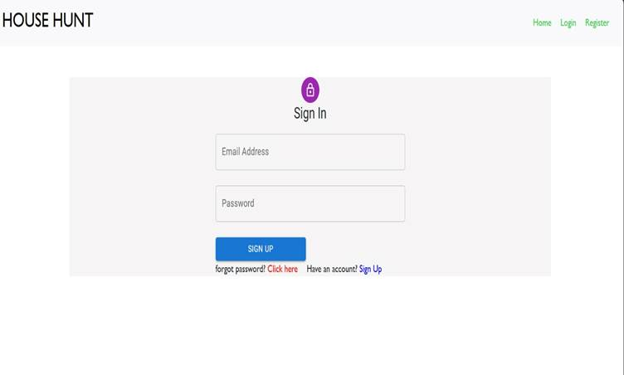
Figure 4. Login interface from the supplied project document.
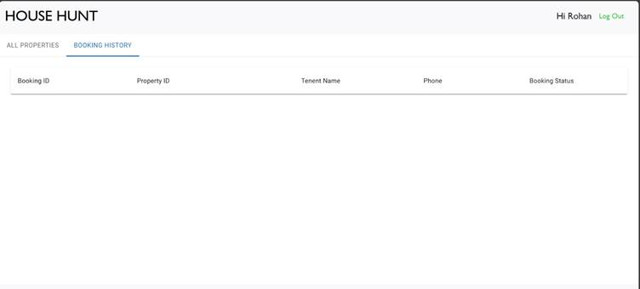
Figure 5. Renter booking-history interface from the supplied project document.
The public application also displays property cards with image, address, type, ad type, amount, contact, availability, and additional information. Owners and administrators use data tables for management tasks.

10. Testing
No reproducible automated test suite or performance report exists in the repository snapshot. The backend package.json test command explicitly exits with 'no test specified'. Therefore, this documentation does not claim fabricated pass rates or response times.
Test Area | Recommended Tool | Minimum Acceptance
API functional | Postman/Newman | All endpoints return expected status and response schema
Authorization | Jest/Supertest | Wrong roles receive 403; missing/invalid JWT receives 401
UI | React Testing Library | Registration, login, filtering, and booking flows render and handle errors
Load | k6/JMeter | At 25 concurrent read users, p95 < 2 seconds and error rate < 1%
Security | OWASP ZAP + review | No unauthenticated state change; verified reset; restricted uploads

11. Screenshots and Demo
Source repository: https://github.com/naveenduvva692004-collab/house-rent-master
The earlier draft contains a Google Drive demo link. Confirm that the team owns the video and that sharing permissions work before including it in the final submission.

12. Known Issues
Issue | Evidence / Impact | Recommended Fix
API port mismatch | Frontend uses 8001; backend fallback is 8000 | Environment-based API base URL and matching PORT
Missing role authorization | JWT middleware checks only identity | Require Admin/Owner/Renter roles per route
Unsafe password reset | Anyone knowing an email can set a new password | Use time-limited verified reset tokens
Booking field mismatch | Schema declares propertId while controllers/UI use propertyId | Rename consistently and migrate data
Flexible schemas | strict:false allows accidental fields | Define explicit granted/isAvailable and use strict schemas
Local uploads | Original filenames can collide; not horizontally scalable | Unique names, type/size limits, cloud object storage
In-memory filtering | Controllers fetch all records and filter in JavaScript | Query MongoDB by owner/user ID and add indexes
No tests | No backend tests and no project UI tests found | Add unit, integration, UI, and load tests

13. Future Enhancements
- Server-enforced role authorization and audit logging.
- Verified email/password recovery and stronger validation.
- Saved searches, favorites, alerts, and owner/renter notifications.
- Geospatial search, maps, and neighborhood information.
- Payment, agreement, identity-verification, and dispute workflows.
- Cloud file storage, deployment configuration, CI/CD, logging, and monitoring.
- Automated test coverage and measurable performance baselines.
- Responsive accessibility improvements and clearer error feedback.

Conclusion
The repository demonstrates the core pieces of a MERN rental workflow: a React client, an Express API, MongoDB persistence, JWT authentication, property management, and booking operations. The system is appropriate for an academic demonstration, while the known security, data-quality, testing, and deployment gaps should be addressed before any real-world use.
Submission note: Team ID and any member-specific role allocation should be confirmed before final academic submission.

